Design Document

for

ClubZen IITK

Version 1.0

Prepared by

Group 12 Group Name: Tiny Coders

|  |  |  |
| --- | --- | --- |
| Akash Biswas | 200074 | [abiswas20@iitk.ac.in](mailto:abiswas20@iitk.ac.in) |
| Avinash Prased | 200231 | [avinashp20@iitk.ac.in](mailto:avinashp20@iitk.ac.in) |
| Chandekar Vidish Vijay | 200291 | [cvvijay20@iitk.ac.in](mailto:cvvijay20@iitk.ac.in) |
| Harshit Gupta | 200429 | [guptah20@iitk.ac.in](mailto:guptah20@iitk.ac.in) |
| Jaya Meena | 200472 | [jayameena20@iitk.ac.in](mailto:jayameena20@iitk.ac.in) |
| Nikhil Verma | 200637 | [nikhilv20@iitk.ac.in](mailto:nikhilv20@iitk.ac.in) |
| Priyal Agrawal | 200730 | [priyalag20@iitk.ac.in](mailto:priyalag20@iitk.ac.in) |
| Priyanka Meena | 200731 | [priyankam20@iitk.ac.in](mailto:priyankam20@iitk.ac.in) |
| Shreyasi Mandal | 200956 | [shreyansi20@iitk.ac.in](mailto:shreyansi20@iitk.ac.in) |
| Vartika | 201089 | [vartikag20@iitk.ac.in](mailto:vartikag20@iitk.ac.in) |

|  |  |
| --- | --- |
| Course: | CS253 |
| Mentor TA: | Aishwarya Gupta |
| Date: | 15.02.2022 |

Content

Contents ii

Revisions ii

1 Context Design 1

1.1 Context model 1

1.2 human Interface Design 1

2 Architecture design 12

3 object-oriented design 13

3.1 Use case diagram 13

3.2 Class diagram 22

3.3 sequence diagram 3

3.4 State diagram 3

4 Project Plan 4

5 Other Requirements 5

Appendix A - Group Log 6

Revisions

| Version | Primary Author(s) | Description of Version | Date Completed |
| --- | --- | --- | --- |
| v1.0 | Group 12 – Tiny Coders | SDS 1.0 | 15/02/22 |

# Context Design

## Context Model

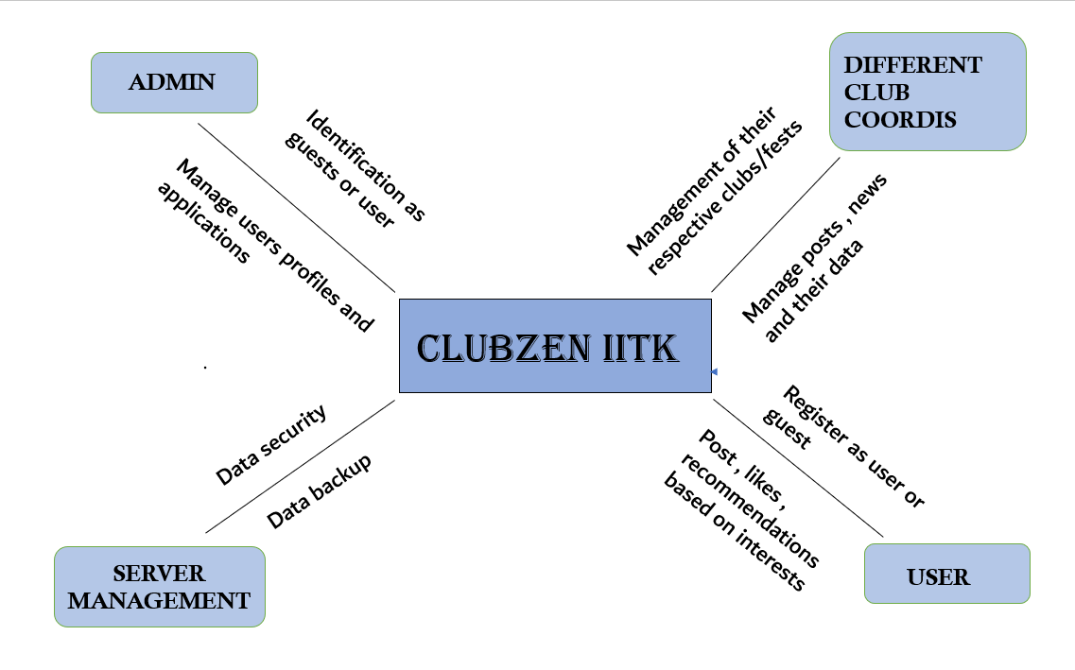

## Human Interface Design

**User Flow Description**

Users start from the Login Screen which has 3 options: Login, Reset Password and Sign-up (as a New Member). The user returns to the login screen if they logout from application or cancel sign up or rest process.

Once the login is successful the moves on to the home screen which is the central location for the following functionalities:-

* News/Feed
* Clubs/Societies/Fests
* Calendar
* Forum
* Profile

**User Flow Design**

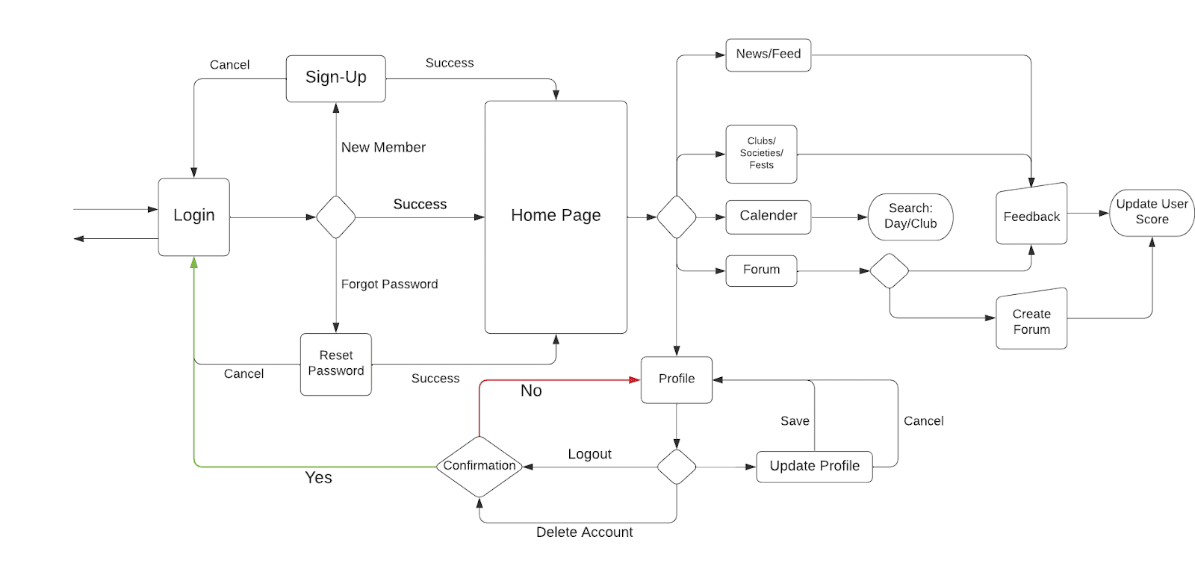

* + 1. **Login and Sign-up Page**

In order to use ClubZen, the User has to Login first. If they don’t have an account set up they can either log in as a Guest or Sign Up.

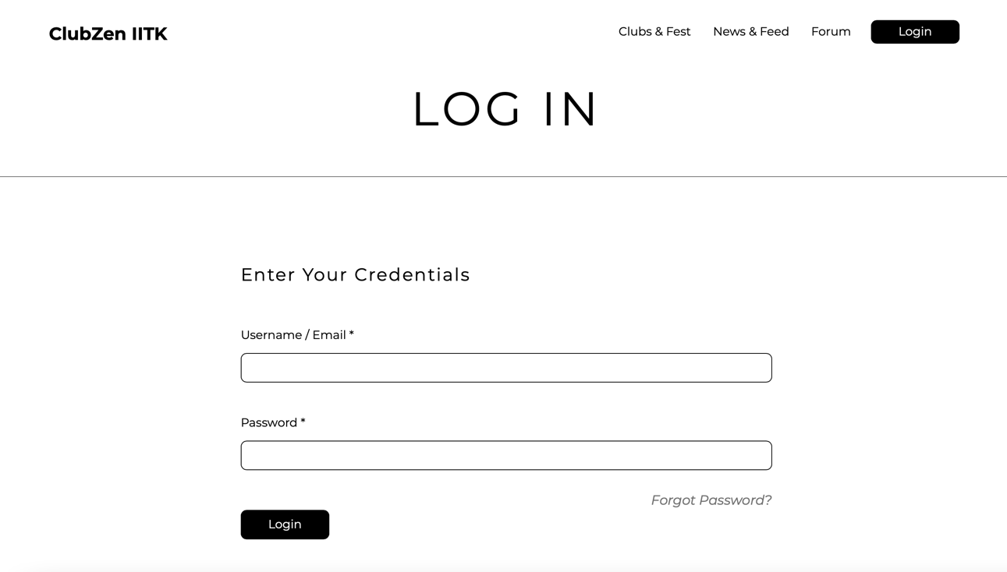

**Login Window:** Users have to enter their Credentials in order to Log in.

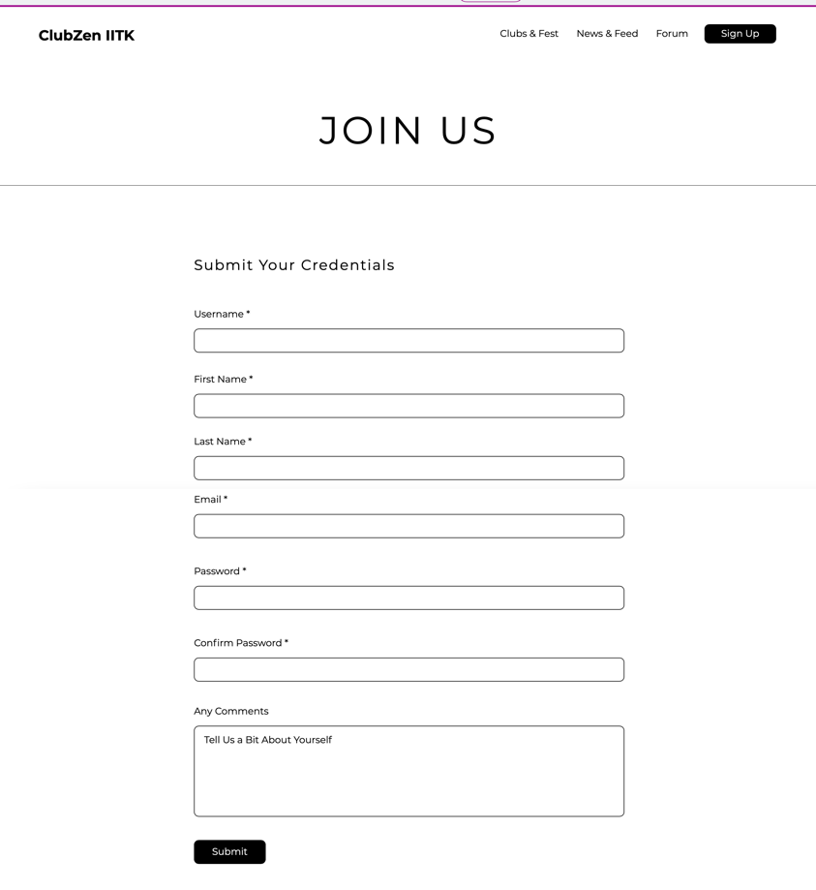

**Signup Window:** New Users have to create a new profile in order to use ClubZen. It is done by providing valid Credentials.

* + 1. **Home Page**

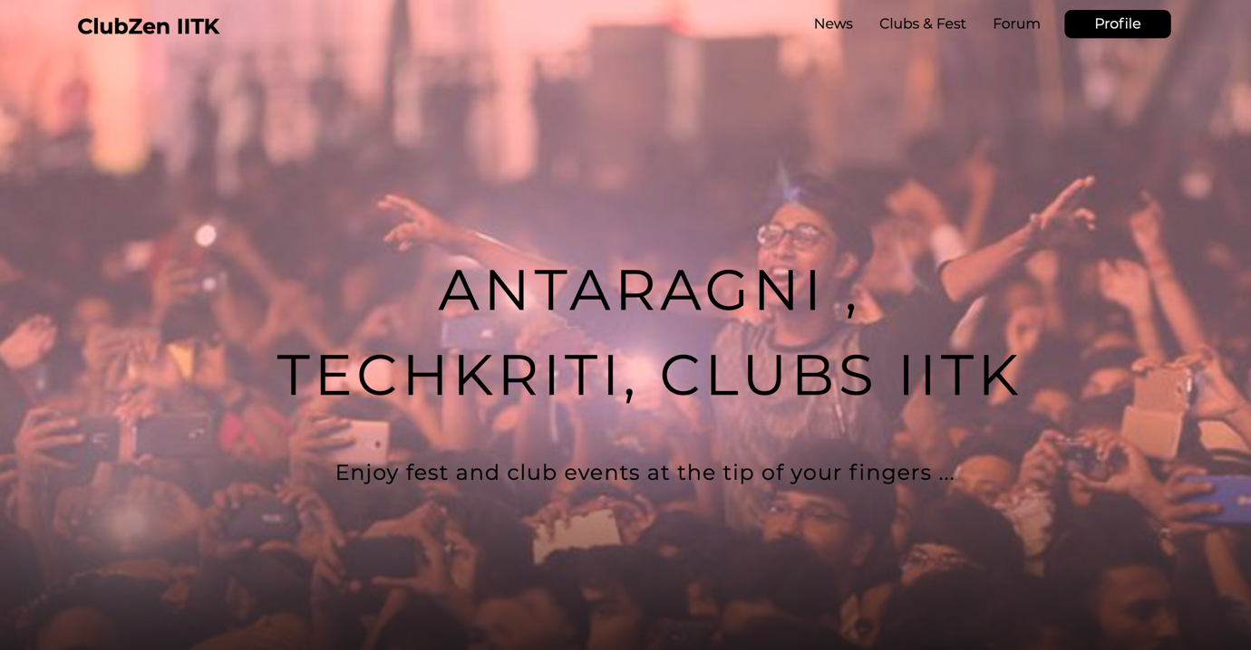

The home screen is the central location for all the users. Users can check the latest news, explore various councils of IIT Kanpur and festivals at IIT Kanpur in a nutshell, join the discussion – explore the forum etc.

The users can navigate to different pages as per their wish.



**Latest News:** This section in the home page will be updated every time a new notice is posted in the ‘News’ page.

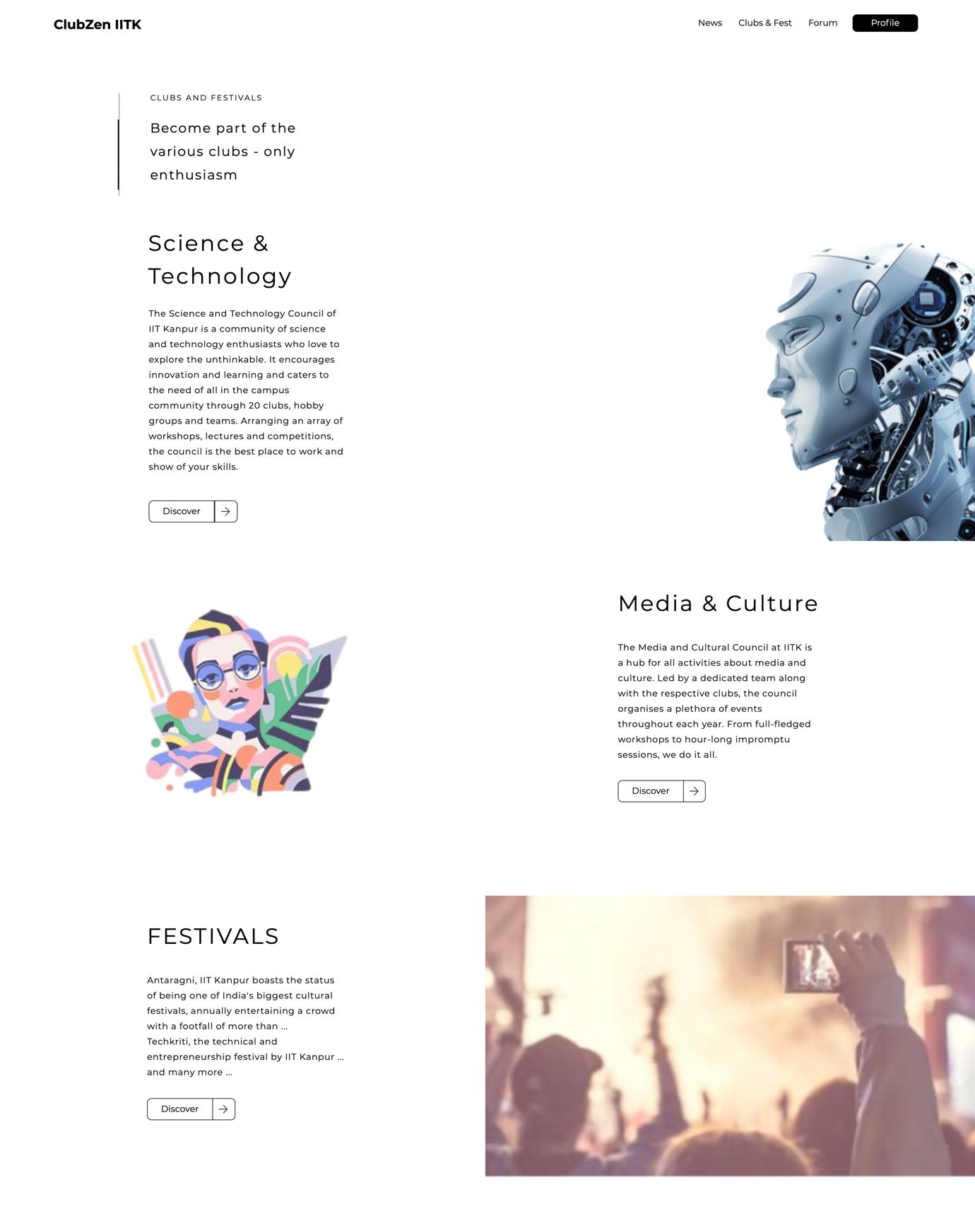

**Clubs & Festivals:** This section shows all the councils and festivals celebrated in a nutshell.



**Forum:** This section takes you to the ‘Forum’ page where one can post their questions and doubts.

* + 1. **News and Feeds**

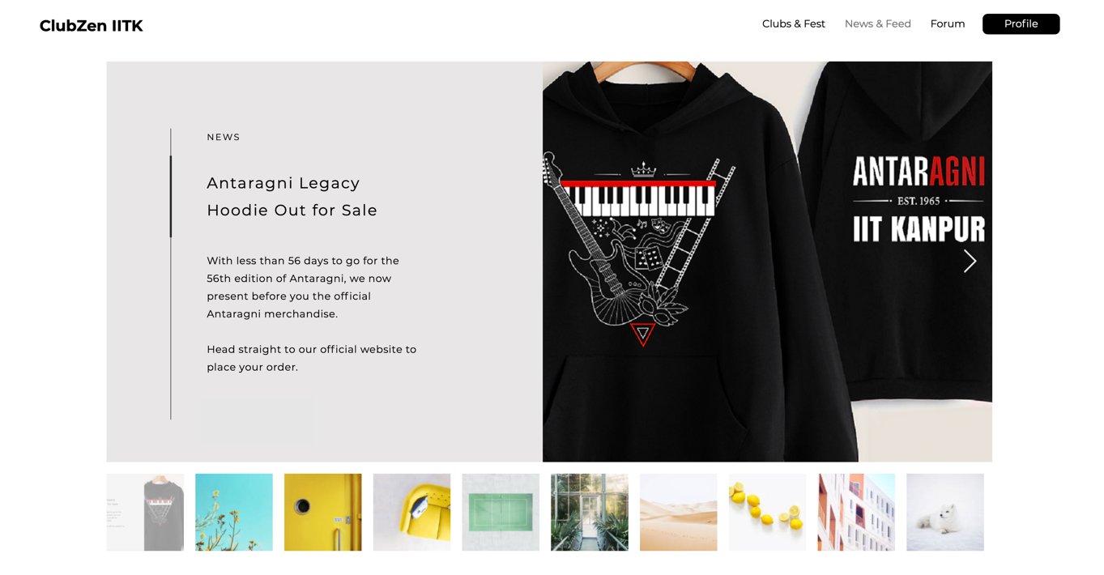

**News:** This section will provide the users with information related to the current events, workshops, competitions and others organized by various clubs in a nutshell. More information regarding these will be found on the respective club’s page.

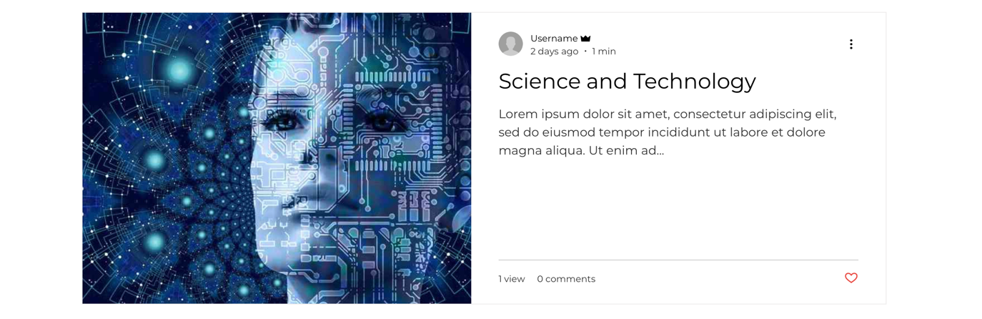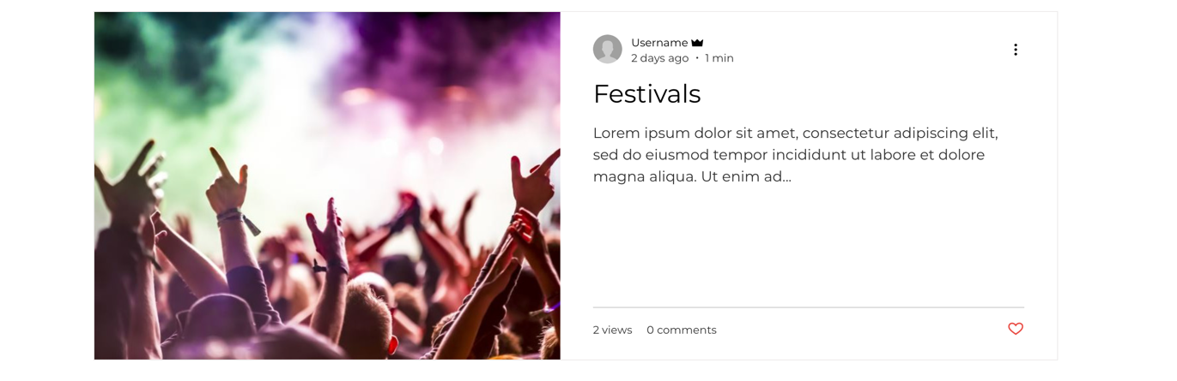

**Feed:** This section displays the various posts a user or admin creates.

The users can like the posts, post comments etc. While creating the posts, an user has the option to add pictures, videos, lists and many more.

Only the creators of the posts will be able to modify or delete them.

The posts will have different tags or categories – specifying the different clubs with which they are associated respectively.

If a user posts above a certain number of posts, a badge will be awarded to them.

A badge will also be awarded if the users receive above a certain number of likes or comments.

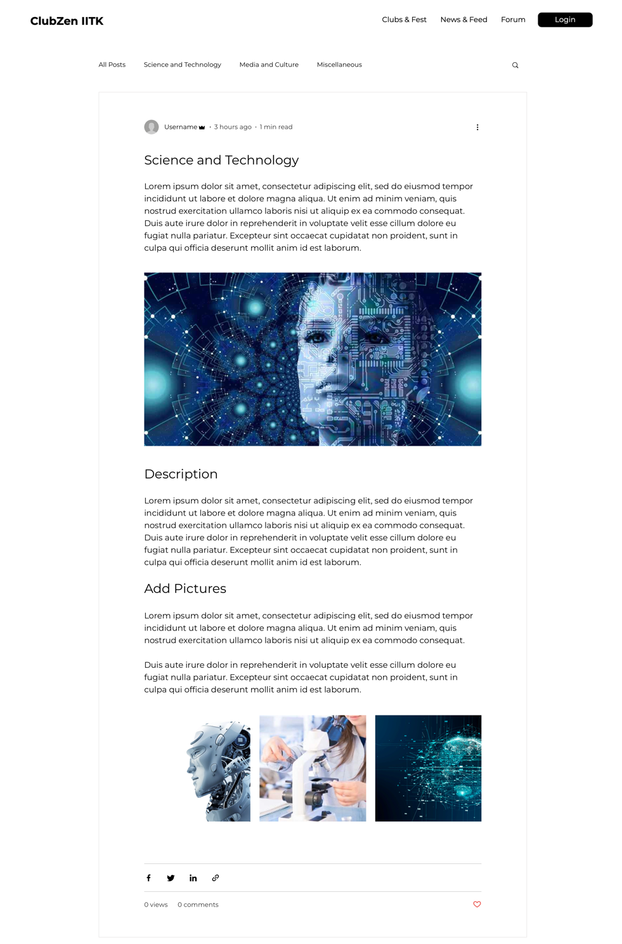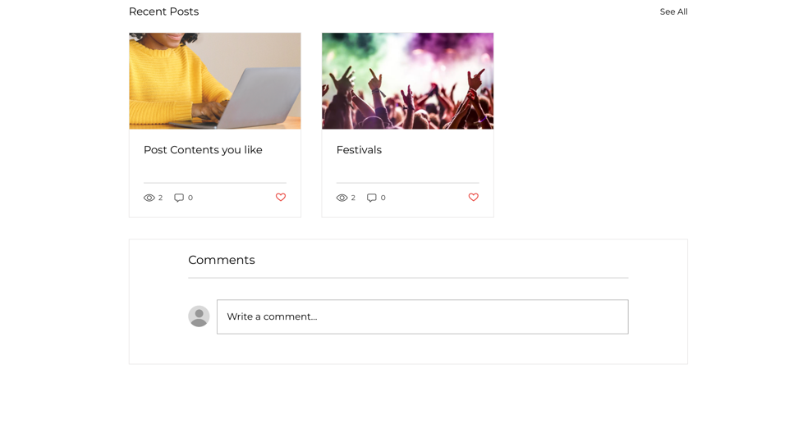

* + 1. **Clubs and Festivals**

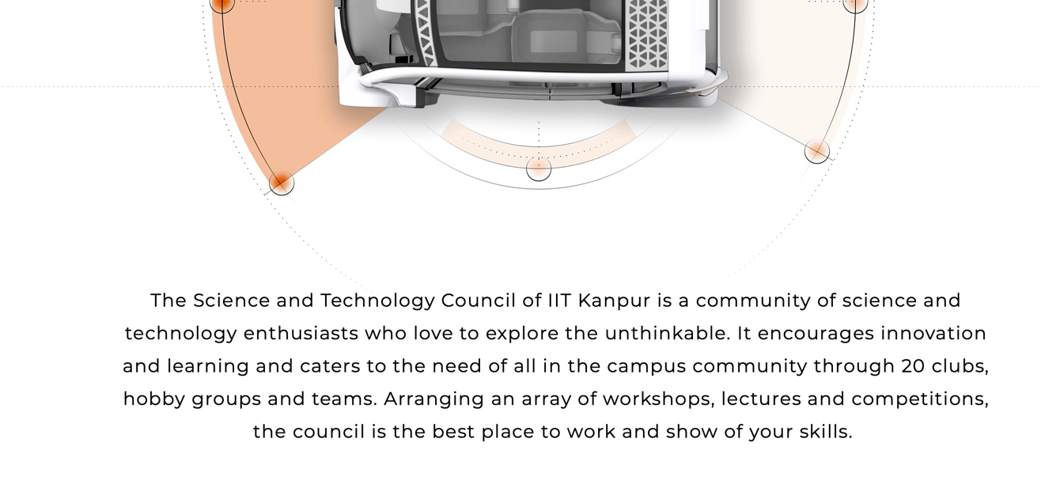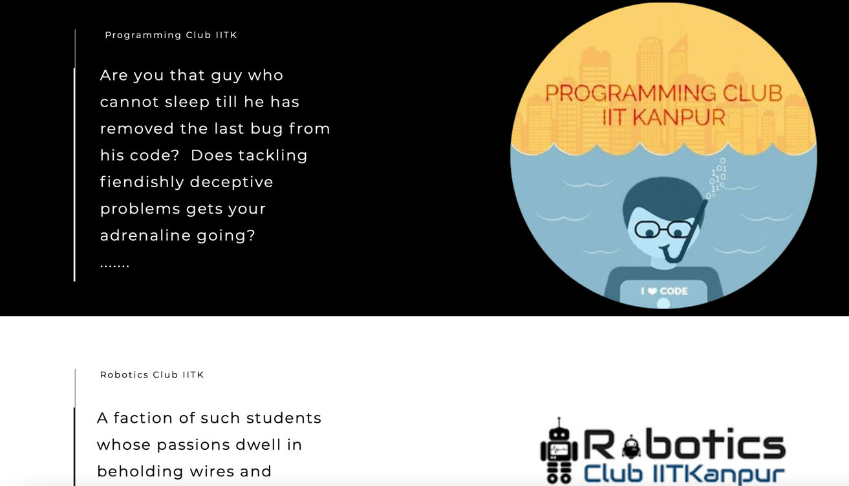

This page lists out the clubs present in the respective council and takes the users to the respective club pages.

Through this window, the Users can view relevant information regarding the Clubs, Societies and Fests they are interested in. Every Club/Society/Fest will have their own Page which will be managed by the Coordinator/Team of the respective Club/Society/Fest. Relevant Information would include upcoming Events, Workshops, Competitions as well as past Achievements and Accomplishments.

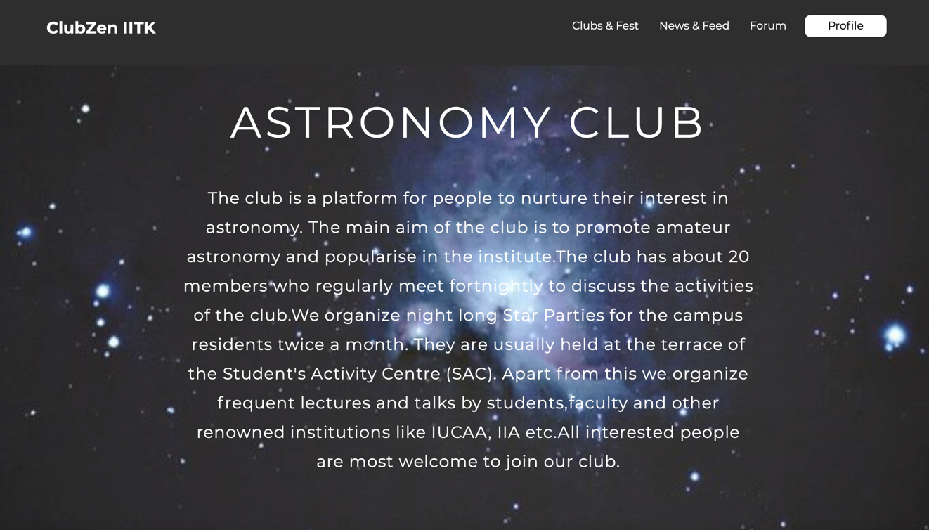

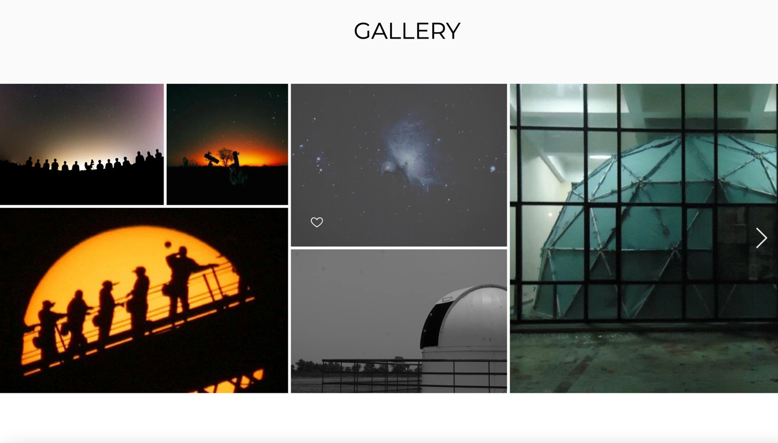

**Gallery:** This section shows all the pictures and videos posted by various members of the club or other users who wish to be a member of the respective club.

* + 1. **Forum**

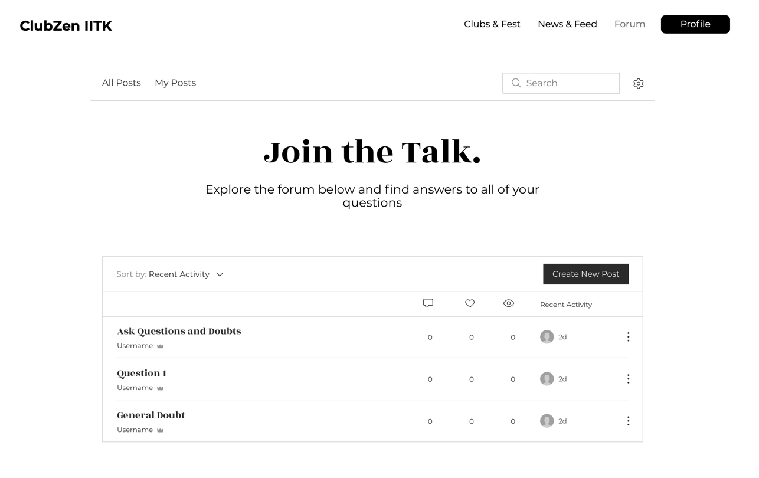

Users can interact with each other through Forums by asking doubts/posting questions and answering them.

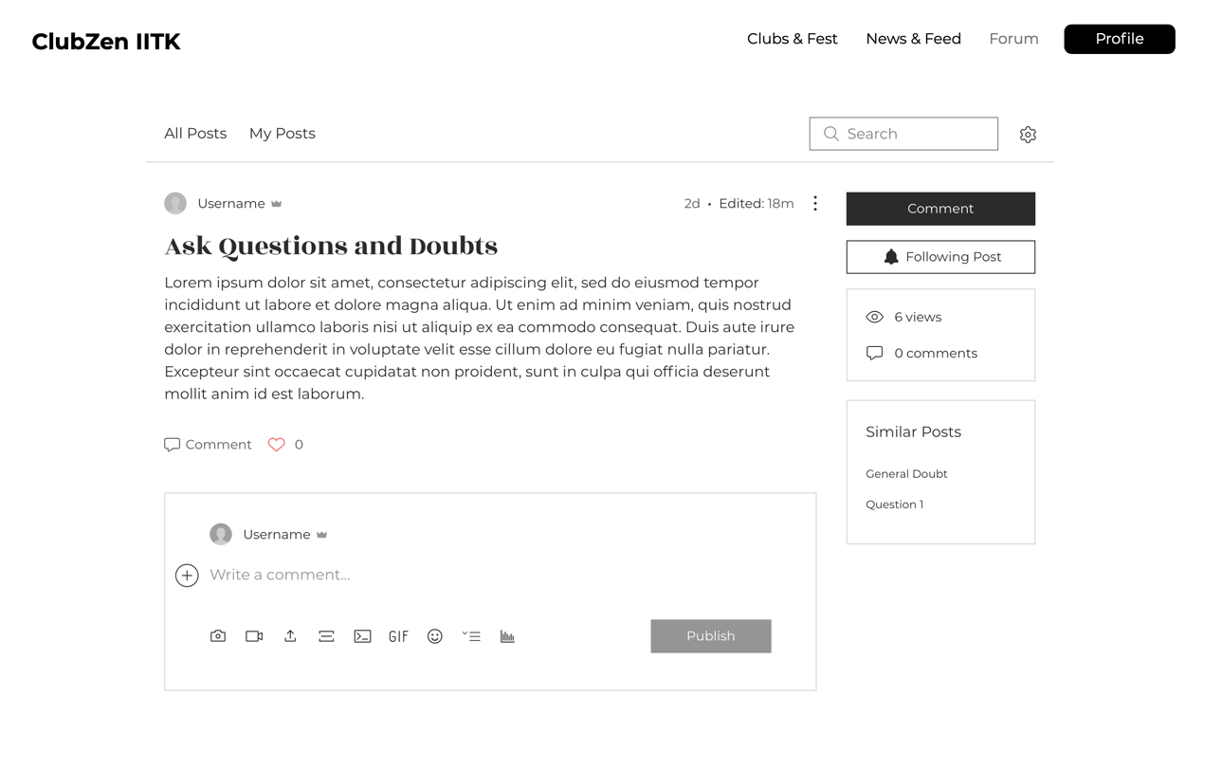

* + 1. **Profile – My Account**

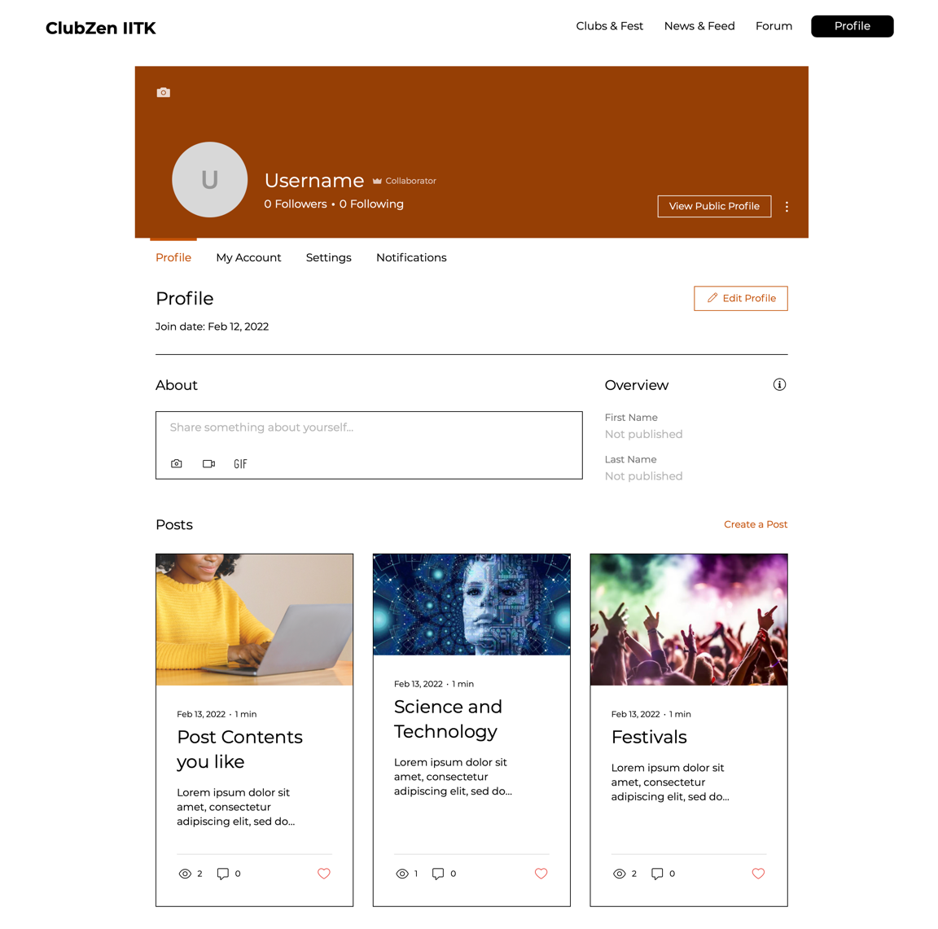

The above shows the public profile of a user – visible to everyone. The public profile of a user also shows the various posts and/or questions posted or asked by the user.

In the ‘**Settings**’ page (only visible to the respective user), notification settings, account deletion, password change settings etc. are present.

The ‘**Notifications**’ can include the following –

* If someone likes or comments on your post
* If someone answers your doubts
* If any news or announcements are made by the clubs of their interest

# Architecture Design

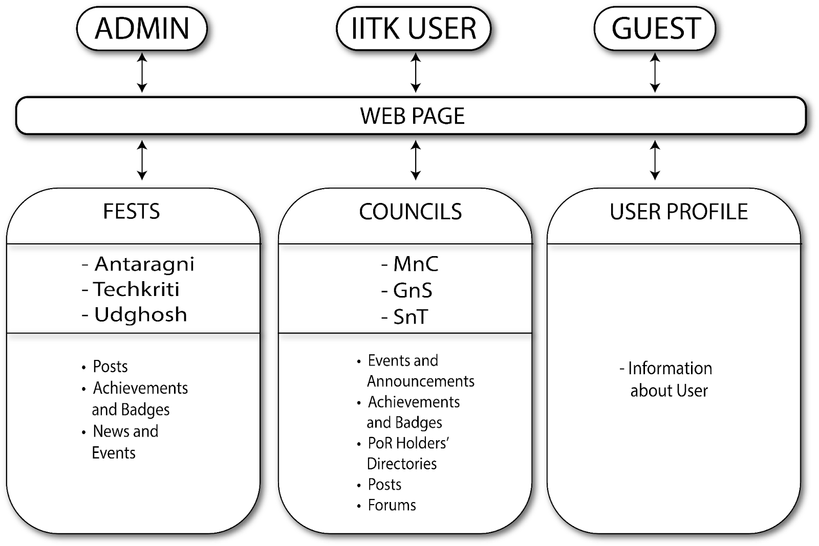

# Object Oriented Design

## Use Case Diagrams

### 3.1.1     Use Case #1: Sign Up and Login

**Purpose** - This use case is for the login and signup of the user/admin/guest.

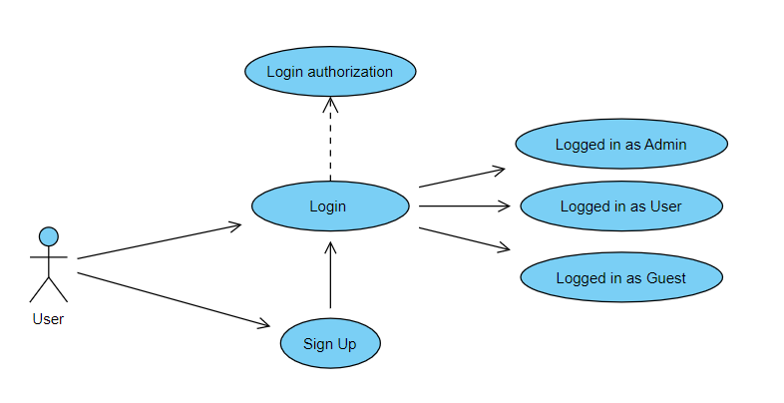

**3.1.2**     **Use Case #2: Forgot Password**

**Purpose** - This use case is for the updating of the user profile (name, profile picture and other details).

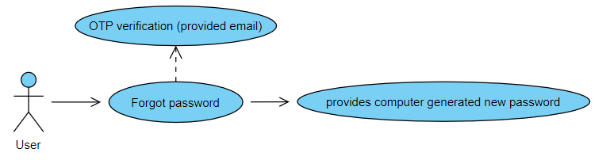

### 3.1.3     Use Case #3: Update Profile

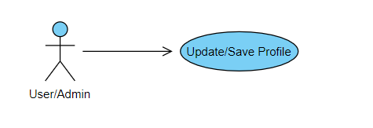

**Purpose** - This use case is for the updating of the user profile (name, profile picture and other details).

**3.1.4**     **Use Case #4: Creation of Club/Fest page**

**Purpose** - This use case is for creating club/events pages.

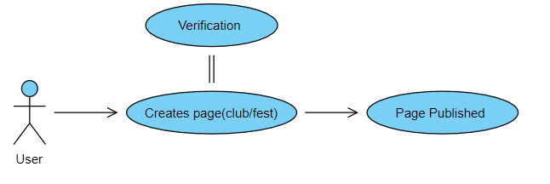

### 3.1.5     Use Case #5: Viewing Activities in Calendar

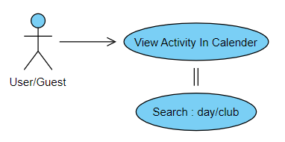

**Purpose** - This use case is used for viewing the schedule of different activities (events and workshops) in the calendar.

### 3.1.6     Use Case #6: Updating Activities in Calendar

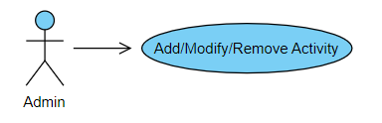

**Purpose** - This use case is for the updating Activity Calendar.

**3.1.7**     **Use Case #7: Posting and Reviewing**

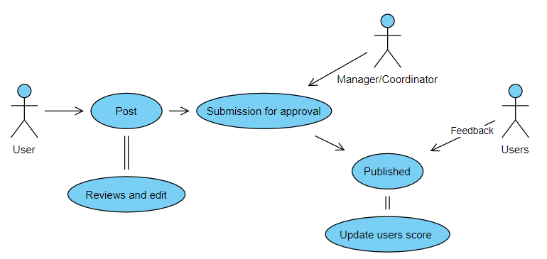

**Purpose** - This use case is triggered when the users want to post something to the club page to showcase their skills and get reviews from admins and other users.

**3.1.8**     **Use Case #8: Add Achievement**

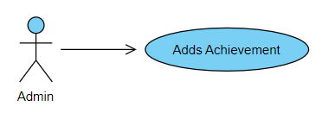

**Purpose** - This use case is for updating the Achievement and Badges section of the club/fest.

**3.1.9**     **Use Case #9: Update Achievement**

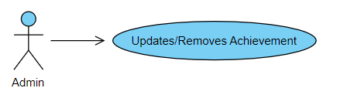

**Purpose** - This use case is for updating the Achievement and Badges section of the club/fest.

**3.1.10**     **Use Case #10: Forums**

**Purpose** - This use case is triggered when the user wants to create a forum to interact with other users and admins.

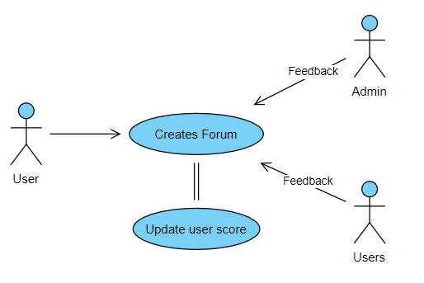

**3.1.11**   **Use Case #11: Distribution of badge**

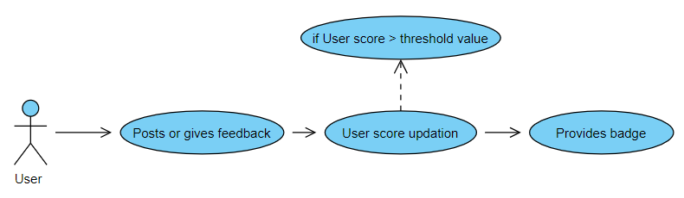

**Purpose** - This use case is triggered when the user posts or comments something on someone’s post or reply to forums.

**3.1.12**     **Use Case #12: Logout**

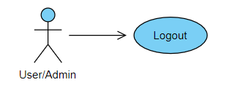

**Purpose** - This use case is triggered when the user wants to logout.

## Class Diagrams

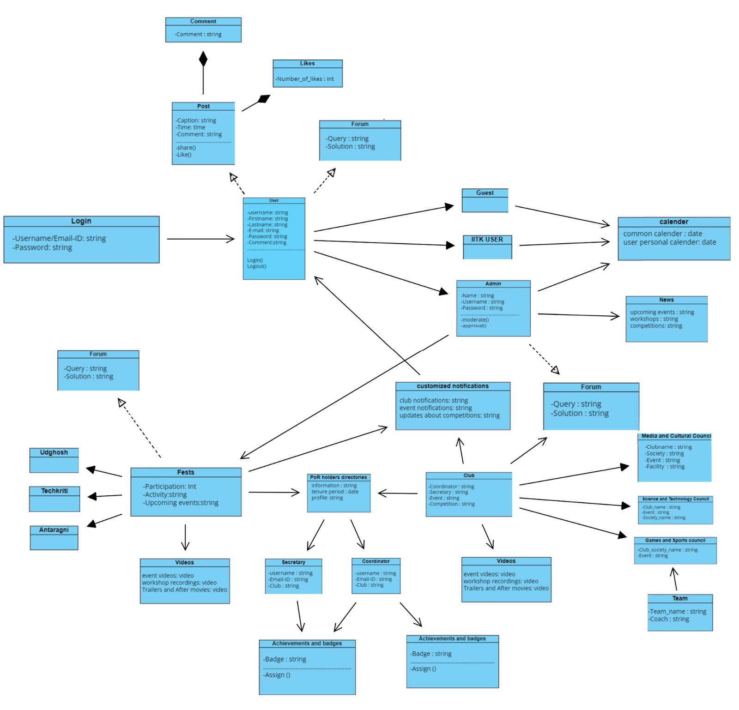

## Sequence Diagrams

1. Login

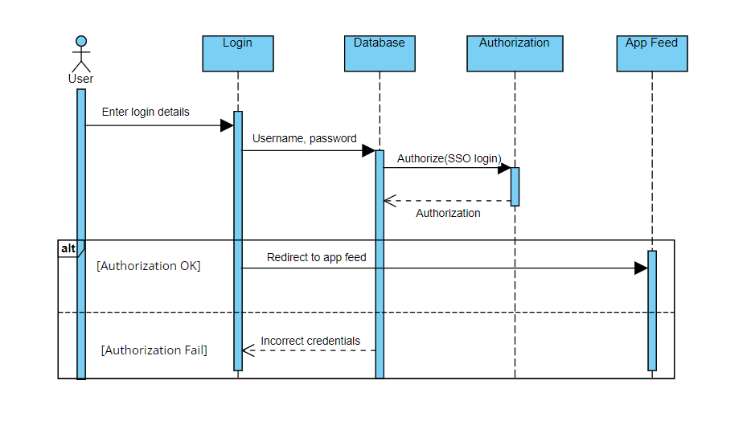

1. Register

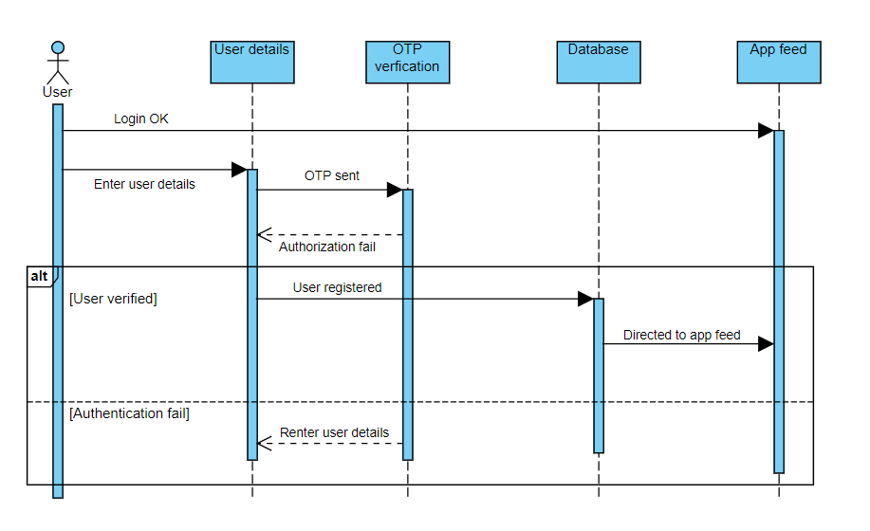

1. Forgot Password

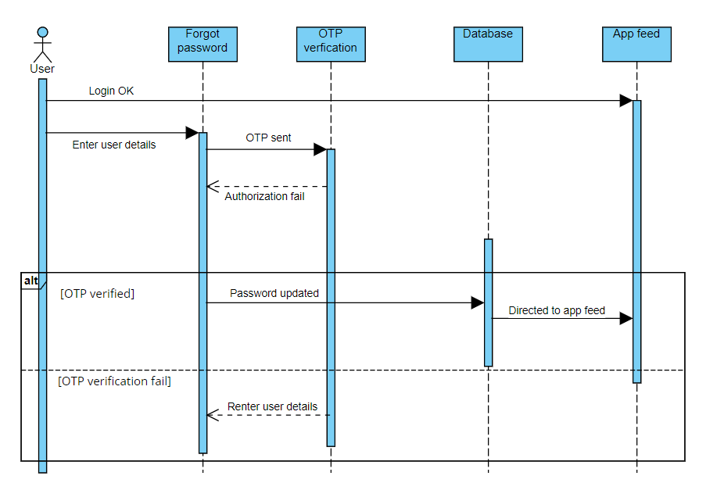

1. Profile Page Updating

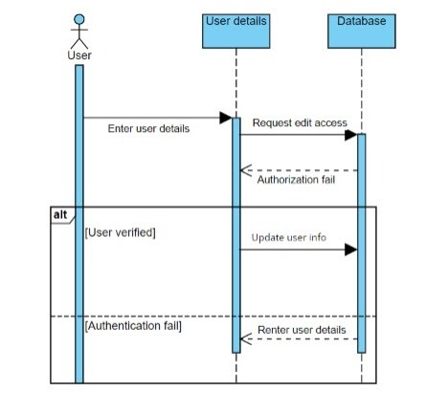

1. Club / Fest Page Creation

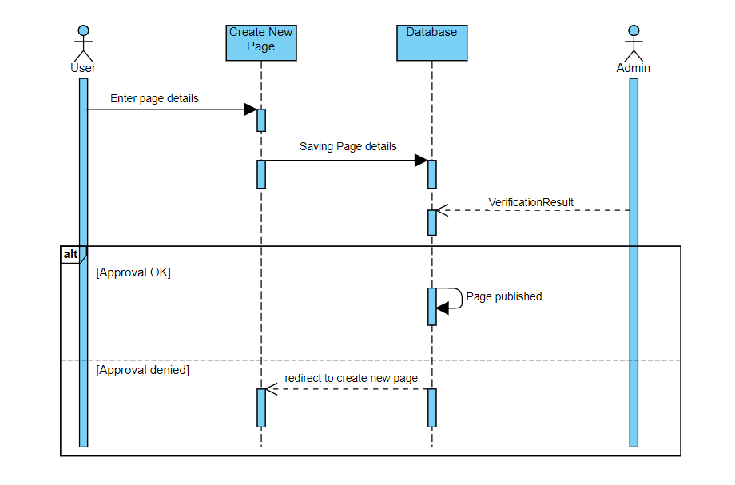

1. View Calendar

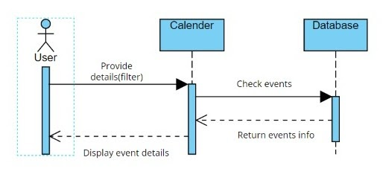

1. Edit Calendar

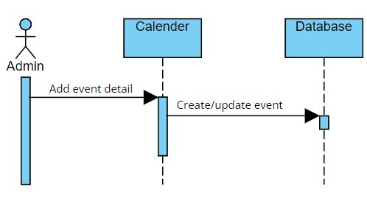

1. Forum

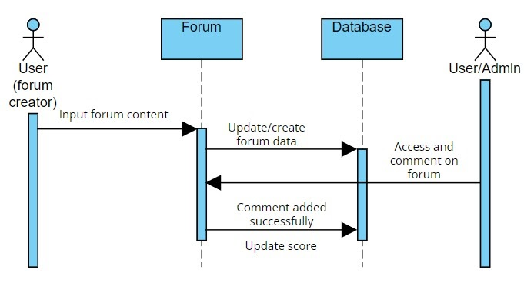

1. Add / Update Achievements

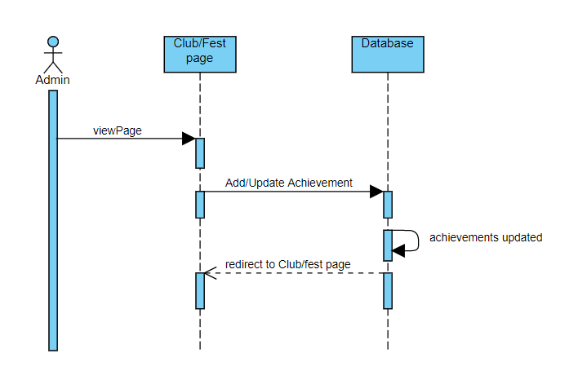

1. Badge Distribution

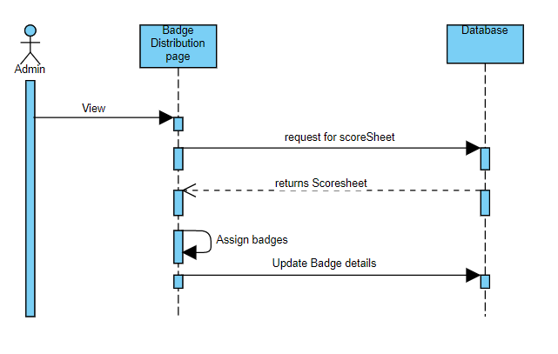

1. Posting and Reviewing

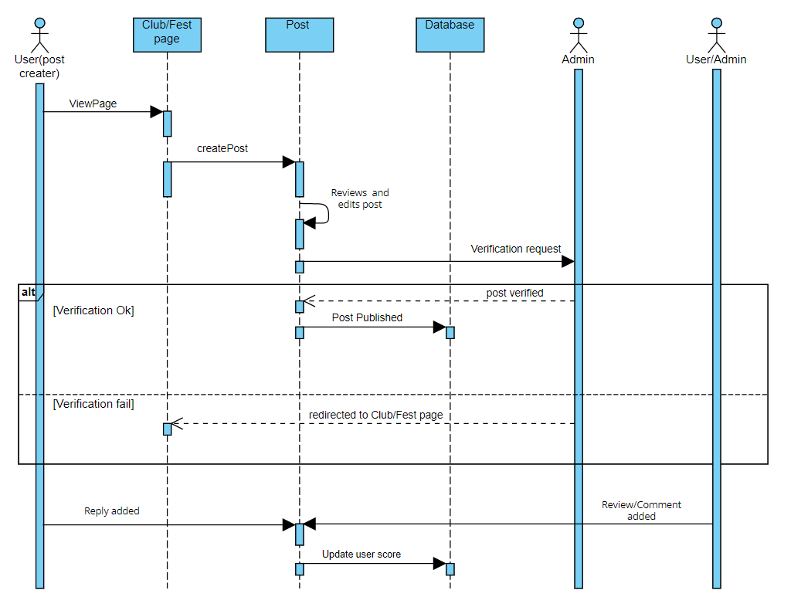

## State Diagrams

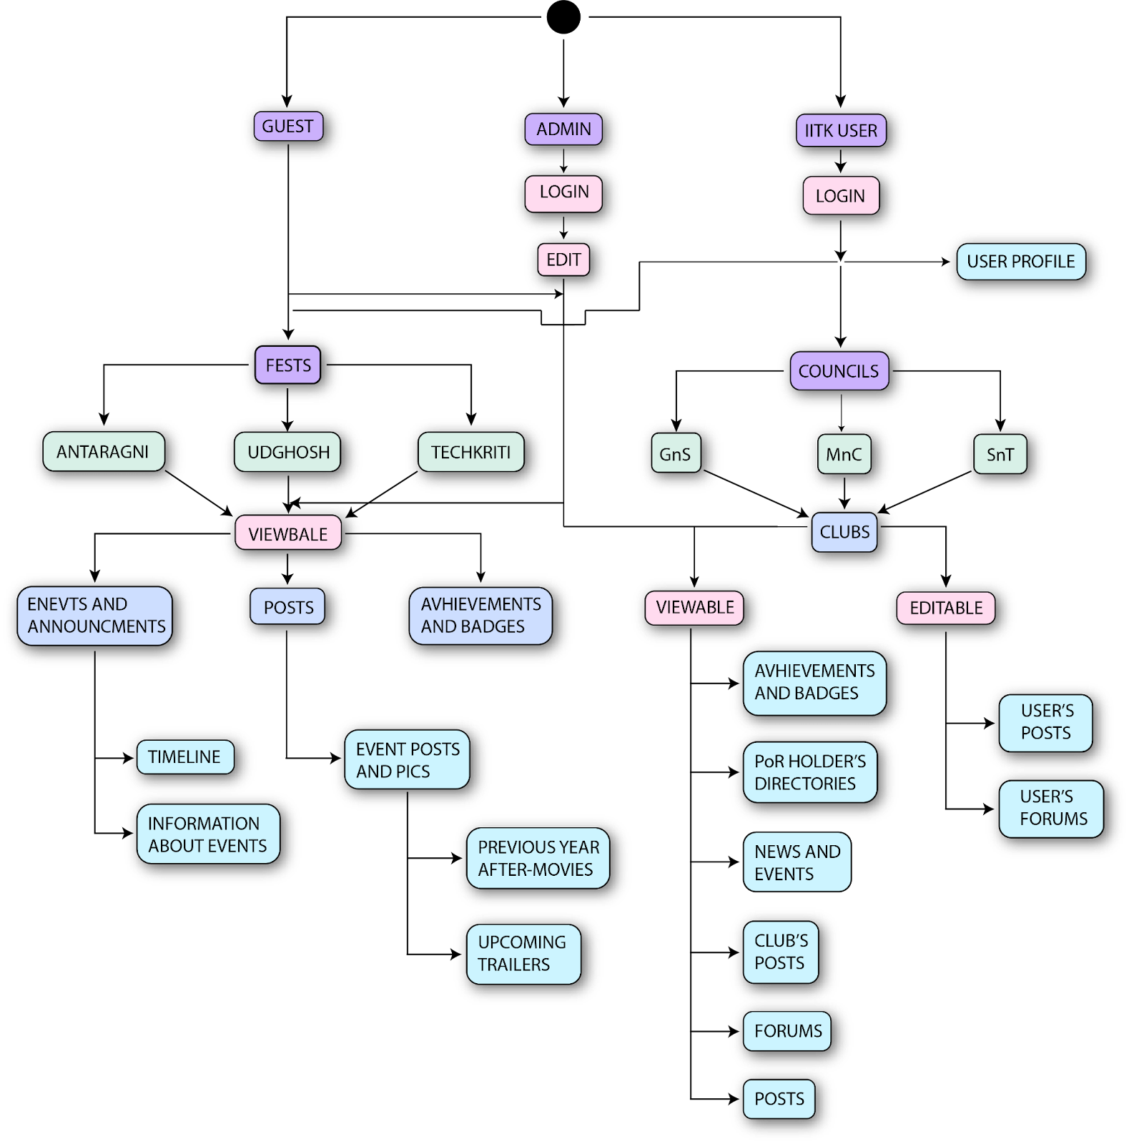

# Project Plan

Timeline of the development of ClubZen:-

1. 16th January 2022 - 1st February 2022: Documentation of Software Requirements Specification (SRS).
2. 2nd February 2022 - 15th February 2022: Documentation of Software Design Documentation.
3. 16th February 2022 - 13th March 2022: Implementation and Testing:- Member wise classification of tasks as well as the required software is given below. Major tasks including writing the source code, designing the web page, making and testing unit as well as integrated test cases and implementing a secure Firewall would be done during this time. Testing would be done by members of respective functions.
4. 14th March 2022 - 27th March 2022: System and Manual Beta Testing:- Further necessary testing would be done during this week. This would include testing the system as a developer as well as (Beta) testing as an End User.
5. 28th March 2022 - 10th April 2022: Code Improvement and Beta Testing:- With the results of the previous testing sessions, improvements on the software would be done to increase speed, security and its overall quality.
6. 11th April 2022 -  22nd April 2022: Addressing Beta Testing Feedback and Delivering the Final Project Report

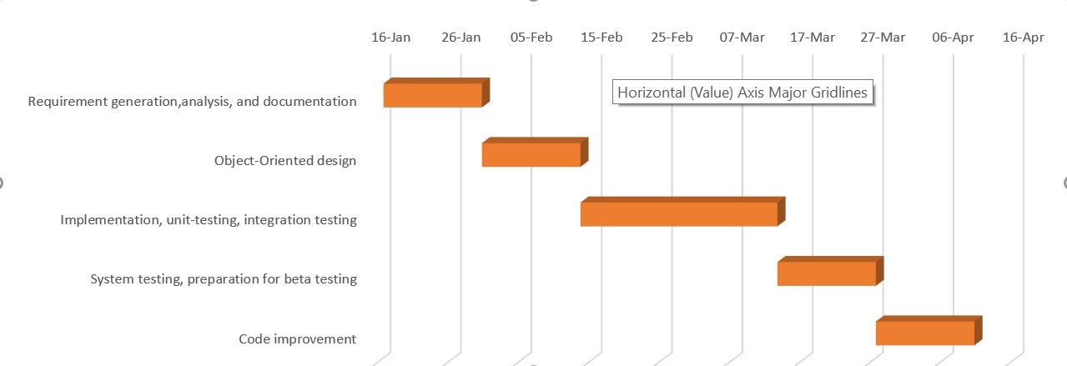

The following are the broad classification of the tasks along with the names of team member responsible for it:-

1. **Front End Design:** A front-end designer not only creates the aesthetics and wireframes for the product but also turns them into reality via code. Any component of the website which the end User is able to manipulate can be classified as Front End.

The members responsible for Front End Development are:-

1. Shreyasi Mandal (Interfaces: Home Page, News/Feed, Clubs/Fests)
2. Priyanka Meena (Interfaces: Profile, Calendar, Forum)
3. Vidish Chandekar (Interfaces: Log-in, Signup, Reset Password)

The following software might be useful for Front End Development:-

1. React JS:  A free and open-source front-end JavaScript library for building user interfaces based on UI components.
2. JavaScript: JavaScript, often abbreviated JS, is a programming language that is one of the core technologies of the World Wide Web, alongside HTML and CSS.
3. HTML: A standard markup language for documents designed to be displayed in a web browser.
4. CSS: Cascading Style Sheets is a style sheet language used for describing the presentation of a document written in a markup language such as HTML.

1. **Back End Development:** It is everything that the users don't see and contains behind-the-scenes activities that occur when performing any action on a website. It focuses primarily on databases, backend logic, APIs, and Servers.

The members responsible for Back End Development are:-

1. Avinash Prasad (Databases and Caching)
2. Vartika (Firewall and Security)
3. Nikhil Verma (Databases and Secure Networking)
4. Priyal Agrawal (Databases and Cloud Computing)
5. Harshit Gupta (Databases and APIs)
6. Akash Biswas (Databases and APIs)
7. Jaya Meena (Databases and Web Security)
8. Shreyasi Mandal (Cloud Computing)
9. Priyanka Meena (Databases and Networking)
10. Vidish Chandekar (Network and Web Security)

The following software might be useful for Back End Development:-

1. JavaScript: Can be used for both Front and Back End Development.
2. MySQL: MySQL is an open-source relational database management system.
3. Node.JS: Node.js is an open-source, cross-platform, back-end JavaScript runtime environment that runs on the V8 engine and executes JavaScript code outside a web browser.
4. MongoDB: MongoDB is a free and open-source document-oriented database that is very much popular among web developers.

# Other Requirements

Appendix A - Group Log

|  |  |  |  |
| --- | --- | --- | --- |
| S. no. | Date | Timing | Description |
| 1 | 8/02/2022 | 9:30 pm - 10:15 pm | Studied the template given and distributed the work amongst the team members. Also distributed the team according to the development roles. |
| 2 | 9/02/2022 | 4 pm - 7 pm | Met in person with the group members and collaboratively proceeded with the sections of the design document. |
| 3 | 11/02/2022 | 5:45 pm - 6:30 pm | Redistributed the remaining work and reviewed the progress of the design document. |
| 4 | 15/02/2022 | 5 pm - 6 pm | Added final touches to the document and assembled it. |